QVision Operations and Installation Guide

NOTICE

The information in this guide is subject to change without notice.

COMPAQ COMPUTER CORPORATION SHALL NOT BE LIABLE FOR TECHNICAL OR EDITORIAL ERRORS OR OMISSIONS CONTAINED HEREIN; NOR FOR INCIDENTAL OR CONSEQUENTIAL DAMAGES RESULTING FROM THE FURNISHING, PER FORMANCE, OR USE OF THIS MATERIAL.

This guide contains information protected by copyright. No part of this guide may be photocopied or reproduced in any form without prior written consent from Compaq Computer Corporation.

®1992 Compaq Computer Corporation.
All rights reserved. Printed in the U.S.A.

COMPAQ, DESKPRO, SYSTEMPRO, LTE, FASTART
Registered U. S. Patent and Trademark Office.
SLT, EZ help and QVision are registered trademarks of Compaq Computer Corporation.

The software described in this guide is furnished under a license agreement or nondisclosure agreement. The software may be used or copied only in accordance with the terms of the agreement.

Product names mentioned herein may be trademarks and/or registered trademarks of their respective companies.

QVISION GRAPHICS SYSTEM FROM COMPAQ
INSTALLATION AND OPERATIONS GUIDE

First Edition (February 1992)
Second Edition (April 1992)
Text Number 133577-002

Compaq Computer Corporation

QVision Operations and Installation Guide v, vi

FEDERAL COMMUNICATIONS COMMISSION NOTICE

This equipment has been tested and found to comply with the limits for a Class B digital device, pursuant to Part 15 of the FCC Rules. These limits are designed to provide reasonable protection against harmful interference in a residential installation. This equipment generates, uses and can radiate radio frequency energy and, if not installed and used in accordance with the instructions, may cause harmful interference to radio communications. However, there is no guarantee that interference will not occur in a particular installation. If this equipment does cause harmful interference to radio or television reception, which can be determined by turning the equipment off and on, the user is encouraged to try to correct the interference by one or more of the following measures:

- Reorient or relocate the receiving antenna.

- Increase the separation between the equipment and receiver.

- Connect the equipment into an outlet on a circuit different from that to which the receiver is connected.

- Consult the dealer or an experienced radio or television technician for help.

Modifications

The FCC requires the user to be notified that any changes or modifications made to this device that are not expressly approved by Compaq Computer Corporation may void the user's authority to operate the equipment.

Cables

Connections to this device must be made with shielded cables with metallic RFI/EMI connector hoods to maintain compliance with FCC Rules and Regulations.

CANADIAN NOTICE

This equipment does not exceed the Class B limits for radiated emissions as described in the Radio Interference Regulations of the Canadian Department of Communications.

GERMAN NOTICE

COMPAQ computers, when tested with the COMPAQ High-Resolution, Multi-Scanning Color Monitor, were evaluated for compliance to the requirements of ZH1/618 in the Text Mode (640 x 480) using MS-DOS Version 3.31 (or higher) and BASICA as published by COMPAQ.
QVision Operations and Installation Guide vii, viii

CONTENTS

Chapter 1
INTRODUCTION
Product Features 1-2
⎯⎯⎯⎯⎯⎯⎯ ⎯⎯⎯⎯⎯⎯⎯⎯⎯⎯⎯⎯⎯⎯⎯⎯⎯⎯⎯⎯⎯⎯ ⎯⎯⎯⎯⎯

Chapter 2
STARTING UP
Unpacking the Monitor 2-1
⎯⎯⎯⎯⎯⎯⎯ ⎯⎯⎯⎯⎯⎯⎯⎯⎯⎯⎯⎯⎯⎯⎯⎯⎯⎯⎯⎯⎯⎯ ⎯⎯⎯⎯⎯
Connecting the Monitor to a Computer 2-2
⎯⎯⎯⎯⎯⎯⎯ ⎯⎯⎯⎯⎯⎯⎯⎯⎯⎯⎯⎯⎯⎯⎯⎯⎯⎯⎯⎯⎯⎯ ⎯⎯⎯⎯⎯
Operating the Monitor 2-6
⎯⎯⎯⎯⎯⎯⎯ ⎯⎯⎯⎯⎯⎯⎯⎯⎯⎯⎯⎯⎯⎯⎯⎯⎯⎯⎯⎯⎯⎯ ⎯⎯⎯⎯⎯
Pre-Set Modes 2-6
⎯⎯⎯⎯⎯⎯⎯ ⎯⎯⎯⎯⎯⎯⎯⎯⎯⎯⎯⎯⎯⎯⎯⎯⎯⎯⎯⎯⎯⎯ ⎯⎯⎯⎯
User-Modes 2-6
⎯⎯⎯⎯⎯⎯⎯ ⎯⎯⎯⎯⎯⎯⎯⎯⎯⎯⎯⎯⎯⎯⎯⎯⎯⎯⎯⎯⎯⎯ ⎯⎯⎯⎯
Storing Modes 2-7
⎯⎯⎯⎯⎯⎯⎯ ⎯⎯⎯⎯⎯⎯⎯⎯⎯⎯⎯⎯⎯⎯⎯⎯⎯⎯⎯⎯⎯⎯ ⎯⎯⎯⎯
Controls and Indicators 2-8

Chapter 3
CARE AND MAINTENANCE
Protecting the Monitor 3-1
⎯⎯⎯⎯⎯⎯⎯ ⎯⎯⎯⎯⎯⎯⎯⎯⎯⎯⎯⎯⎯⎯⎯⎯⎯⎯⎯⎯⎯⎯ ⎯⎯⎯⎯⎯
Cleaning the Monitor 3-2
⎯⎯⎯⎯⎯⎯⎯ ⎯⎯⎯⎯⎯⎯⎯⎯⎯⎯⎯⎯⎯⎯⎯⎯⎯⎯⎯⎯⎯⎯ ⎯⎯⎯⎯⎯
Shipping the Monitor 3-2
⎯⎯⎯⎯⎯⎯⎯ ⎯⎯⎯⎯⎯⎯⎯⎯⎯⎯⎯⎯⎯⎯⎯⎯⎯⎯⎯⎯⎯⎯ ⎯⎯⎯⎯⎯
Servicing the Monitor 3-3
⎯⎯⎯⎯⎯⎯⎯ ⎯⎯⎯⎯⎯⎯⎯⎯⎯⎯⎯⎯⎯⎯⎯⎯⎯⎯⎯⎯⎯⎯ ⎯⎯⎯⎯⎯
Troubleshooting 3-4
⎯⎯⎯⎯⎯⎯⎯ ⎯⎯⎯⎯⎯⎯⎯⎯⎯⎯⎯⎯⎯⎯⎯⎯⎯⎯⎯⎯⎯⎯ ⎯⎯⎯⎯⎯

Appendix A
SPECIFICATIONS
Acceptable Signal Transmission Schemes A-2
⎯⎯⎯⎯⎯⎯⎯ ⎯⎯⎯⎯⎯⎯⎯⎯⎯⎯⎯⎯⎯⎯⎯⎯⎯⎯⎯⎯⎯⎯ ⎯⎯⎯⎯⎯

Appendix B
NATIONAL POWER CORD SET REQUIREMENTS
U.S. and Canada B-1
⎯⎯⎯⎯⎯⎯⎯ ⎯⎯⎯⎯⎯⎯⎯⎯⎯⎯⎯⎯⎯⎯⎯⎯⎯⎯⎯⎯⎯⎯ ⎯⎯⎯⎯⎯
Other Countries B-2
⎯⎯⎯⎯⎯⎯⎯ ⎯⎯⎯⎯⎯⎯⎯⎯⎯⎯⎯⎯⎯⎯⎯⎯⎯⎯⎯⎯⎯⎯ ⎯⎯⎯⎯⎯

Appendix C
ELECTROSTATIC DISCHARGE
Preventing Electrostatic Discharge C-1
⎯⎯⎯⎯⎯⎯⎯ ⎯⎯⎯⎯⎯⎯⎯⎯⎯⎯⎯⎯⎯⎯⎯⎯⎯⎯⎯⎯⎯⎯ ⎯⎯⎯⎯⎯
Methods of Grounding C-2
⎯⎯⎯⎯⎯⎯⎯ ⎯⎯⎯⎯⎯⎯⎯⎯⎯⎯⎯⎯⎯⎯⎯⎯⎯⎯⎯⎯⎯⎯ ⎯⎯⎯⎯⎯

QVision Operations and Installation Guide 1-1

Chapter 1

INTRODUCTION

The QVision Graphics System from Compaq is designed for easy
installation and operation. To assist you while operating your monitor, this guide contains the following information:

Chapter 1 Provides an introduction to the QVision Graphics System from Compaq.

Chapter 2 Provides instructions for unpacking the monitor and connecting it to a COMPAQ personal computer.
A description of the operating controls has also been
provided.

Chapter 3 Provides instructions for the care and maintenance of the monitor. This chapter also contains a troubleshooting guide.
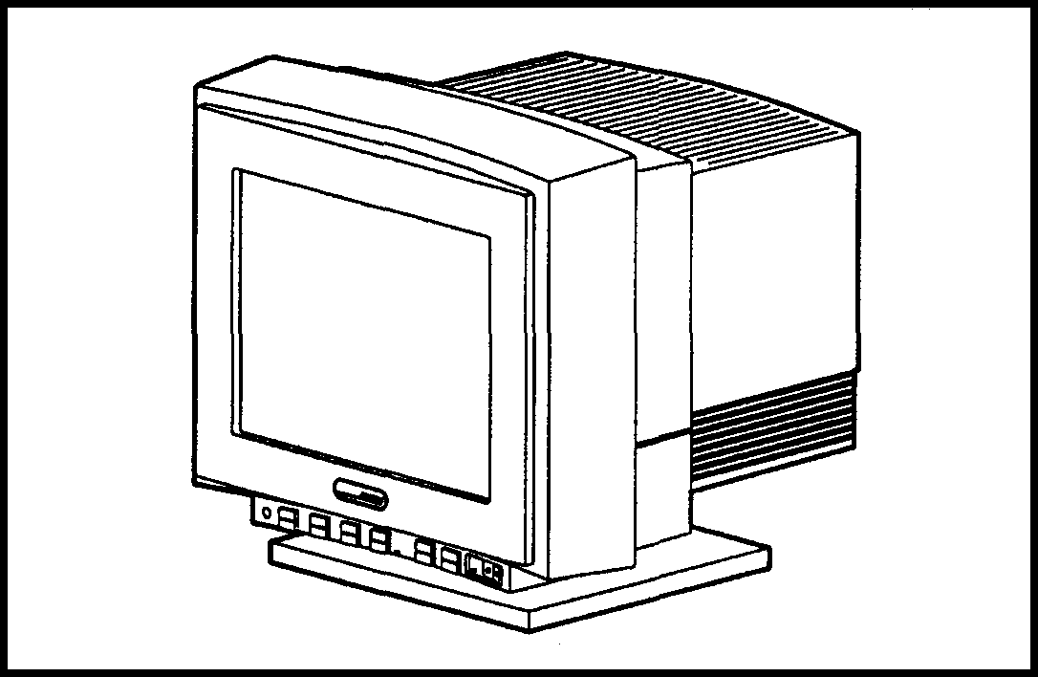
QVision Graphics System from Compaq

QVision Operations and Installation Guide 1-2

PRODUCT FEATURES

- The monitor has a 15- or 17-inch color tube, capable of displaying any color palette resident in the graphics adapter or software application.

- The monitor is compatible with 31 to 58 kHz VGA-type and analog adapters having refresh rates from 50 to 100 Hz.

- The monitor has multi-mode capability and stores the display size and centering parameters for seven preset modes and six user-modes:

⎯⎯⎯⎯⎯⎯⎯⎯⎯⎯⎯⎯⎯⎯⎯⎯⎯⎯⎯⎯⎯⎯⎯⎯⎯⎯⎯⎯⎯⎯⎯⎯⎯⎯⎯⎯

Pre-Set Modes
⎯⎯⎯⎯⎯⎯⎯⎯⎯⎯⎯⎯⎯⎯⎯⎯⎯⎯⎯⎯⎯⎯⎯⎯⎯⎯⎯⎯⎯⎯⎯⎯⎯⎯⎯⎯
1024 x 768 at 72 Hz 1024 x 768 at 66 Hz
⎯⎯⎯⎯⎯⎯⎯⎯⎯⎯⎯⎯⎯⎯⎯⎯⎯⎯⎯⎯⎯⎯⎯⎯⎯⎯⎯⎯⎯⎯⎯⎯⎯⎯⎯⎯
640 x 480 at 60 Hz 640 x 480 at 75 Hz
⎯⎯⎯⎯⎯⎯⎯⎯⎯⎯⎯⎯⎯⎯⎯⎯⎯⎯⎯⎯⎯⎯⎯⎯⎯⎯⎯⎯⎯⎯⎯⎯⎯⎯⎯⎯
720 x 400 at 70 Hz 512 x 480 at 72 Hz
⎯⎯⎯⎯⎯⎯⎯⎯⎯⎯⎯⎯⎯⎯⎯⎯⎯⎯⎯⎯⎯⎯⎯⎯⎯⎯⎯⎯⎯⎯⎯⎯⎯⎯⎯⎯
640 x 350 at 70 Hz
⎯⎯⎯⎯⎯⎯⎯⎯⎯⎯⎯⎯⎯⎯⎯⎯⎯⎯⎯⎯⎯⎯⎯⎯⎯⎯⎯⎯⎯⎯⎯⎯⎯⎯⎯⎯

- The monitor is microprocessor based and can lock onto any scan frequency from 31 kHz to 58 kHz horizontal and 50 Hz to 100 Hz vertical.

- The monitor cable connects to any VGA 15-pin type COMPAQ-compatible system. The monitor has 5 BNC inputs which, with the use of other cables, allow it to be used with almost any type of system. (See Appendix A.)

- The monitor complies with the recommended limits for electrostatic field strength, magnetic field strengths (ELF and VLF) and electric field strengths (ELF and VLF) when measured in accordance with MPR 1990 test methods.

QVision Operations and Installation Guide 2-1

Chapter 2 2-1

STARTING UP

This chapter gives instructions for removing the monitor from its packing material, connecting it to a COMPAQ personal computer, and using the operating controls.

UNPACKING THE MONITOR

⎯⎯⎯⎯⎯⎯⎯⎯⎯⎯⎯⎯⎯⎯⎯⎯⎯⎯⎯⎯⎯⎯⎯⎯⎯⎯⎯⎯⎯⎯⎯⎯
WARNING: The monitor weighs approximately forty-five pounds. Use care when removing it from its packaging material.
⎯⎯⎯⎯⎯⎯⎯⎯⎯⎯⎯⎯⎯⎯⎯⎯⎯⎯⎯⎯⎯⎯⎯⎯⎯⎯⎯⎯⎯⎯⎯⎯

Never insert sharp instruments into the packing box while opening it.

The packing box contains the following items:

- The monitor
- The power cord
- The signal cable
- The QVision Graphics System from Compaq Installation and Operations Guide.

Save the original container and packing material for possible future use.

QVision Operations and Installation Guide 2-2

CONNECTING THE MONITOR

TO A COMPUTER

To connect the monitor to your COMPAQ computer (or to any VGA-type
15-pin connector), follow these steps:

1. Locate the power switch on the lower right side of the monitor face.
Ensure that the power switch is in the OFF (O) position.

⎯⎯⎯⎯⎯⎯⎯⎯⎯⎯⎯⎯⎯⎯⎯⎯⎯⎯⎯⎯⎯⎯⎯⎯⎯⎯⎯⎯⎯⎯⎯⎯
CAUTION: Electrostatic discharge (ESD) can damage electronic components. Ensure that you are properly grounded before beginning this procedure. See Appendix C for ESD information.
⎯⎯⎯⎯⎯⎯⎯⎯⎯⎯⎯⎯⎯⎯⎯⎯⎯⎯⎯⎯⎯⎯⎯⎯⎯⎯⎯⎯⎯⎯⎯⎯
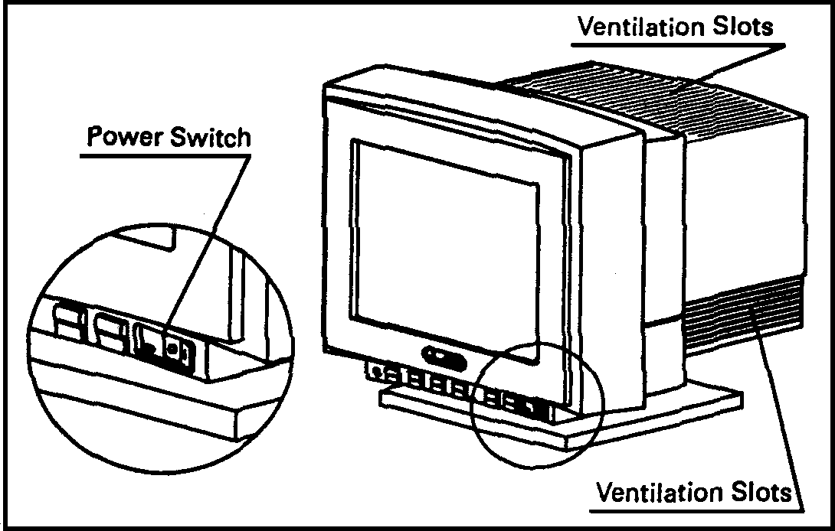
Monitor Power Switch and Ventilation Slots

QVision Operations and Installation Guide 2-3

⎯⎯⎯⎯⎯⎯⎯⎯⎯⎯⎯⎯⎯⎯⎯⎯⎯⎯⎯⎯⎯⎯⎯⎯⎯⎯⎯⎯⎯⎯⎯⎯
WARNING: To prevent possible damage to the video graphic controller board, both the computer and monitor must be OFF before connecting or disconnecting the signal cable.
⎯⎯⎯⎯⎯⎯⎯⎯⎯⎯⎯⎯⎯⎯⎯⎯⎯⎯⎯⎯⎯⎯⎯⎯⎯⎯⎯⎯⎯⎯⎯⎯

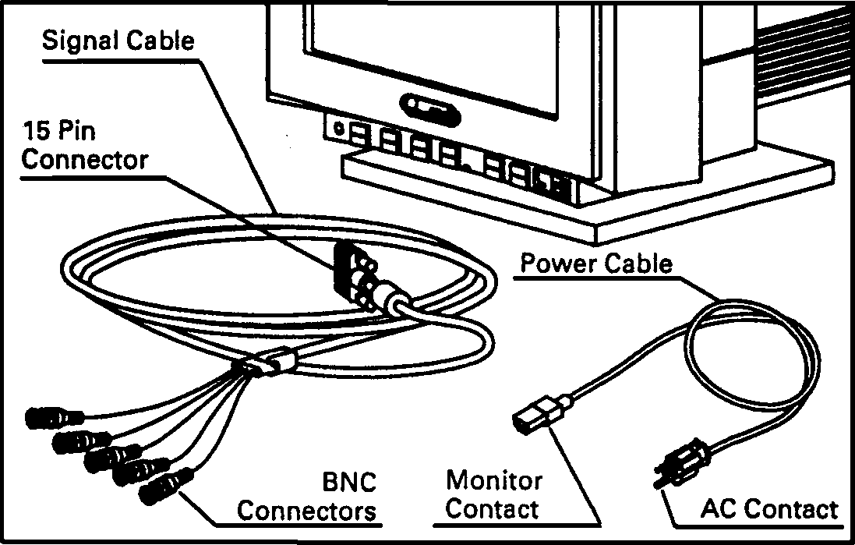

Power and Signal Cables

2. Place the monitor in a convenient, well-ventilated location near your computer. The monitor cabinet has ventilation slots to prevent it from overheating. Be sure nothing blocks these ventilation slots.

3. Connect the monitor contact end of the power cable to the connector on the back of the monitor.

QVision Operations and Installation Guide 2-4

4. Connect the 5 BNC connectors from the signal cable to the monitor. Push in and twist the connectors clockwise until they are locked into place.

The BNC connectors are color-coded from left to right in the following order:

White for horizontal sync (H)
Black for vertical sync (V)
Red (R)
Green (G)
Blue (B) for the video connectors.

Red, green, and blue represent the video connectors.

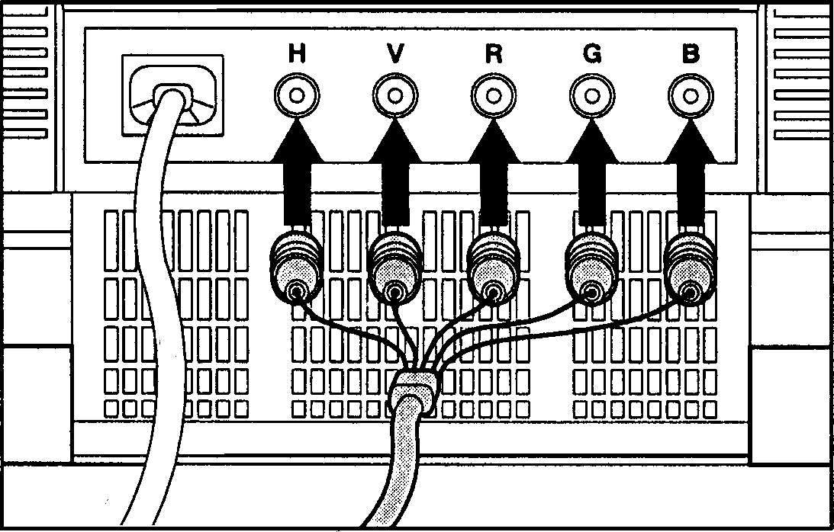

Connecting the 5 BNC Connectors to the Monitor

QVision Operations and Installation Guide 2-5

5. Connect the other end of the signal cable to the 15-pin video graphics connector on the back of your computer.
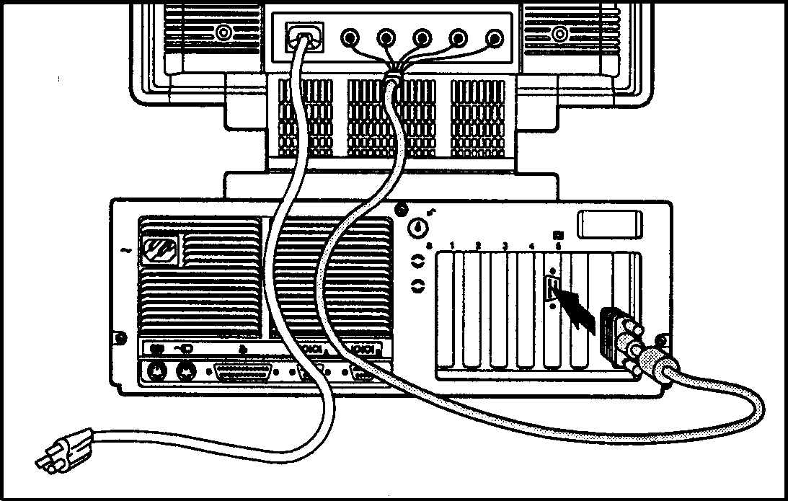

Connecting the Graphic Signal Cable to the 15-Pin Connector

6. Secure the signal cable in place by tightening the screws on the connector by hand.

7. Plug the AC contact end of the power cable into the AC outlet.

QVision Operations and Installation Guide 2-6

OPERATING THE MONITOR

Software applications use drivers to tell the graphics controller installed in your computer which mode to use for any application. The graphics controller, in turn, sends the appropriate signal to the monitor. The QVision Graphics System from Compaq will automatically change modes when your system changes applications.

Pre-Set Modes

The factory default or pre-set modes are the most commonly used modes. The monitor automatically recognizes these modes when they are requested.

⎯⎯⎯⎯⎯⎯⎯⎯⎯⎯⎯⎯⎯⎯⎯⎯⎯⎯⎯⎯⎯⎯⎯⎯⎯⎯⎯⎯⎯
Pre-Set Modes
⎯⎯⎯⎯⎯⎯⎯⎯⎯⎯⎯⎯⎯⎯⎯⎯⎯⎯⎯⎯⎯⎯⎯⎯⎯⎯⎯⎯⎯
1024 x 768 at 72 Hz 1024 x 768 at 66 Hz
⎯⎯⎯⎯⎯⎯⎯⎯⎯⎯⎯⎯⎯⎯⎯⎯⎯⎯⎯⎯⎯⎯⎯⎯⎯⎯⎯⎯⎯
640 x 480 at 60 Hz 640 x 480 at 75 Hz
⎯⎯⎯⎯⎯⎯⎯⎯⎯⎯⎯⎯⎯⎯⎯⎯⎯⎯⎯⎯⎯⎯⎯⎯⎯⎯⎯⎯⎯
720 x 400 at 70 Hz 512 x 480 at 72 Hz
⎯⎯⎯⎯⎯⎯⎯⎯⎯⎯⎯⎯⎯⎯⎯⎯⎯⎯⎯⎯⎯⎯⎯⎯⎯⎯⎯⎯⎯
640 x 350 at 70Hz
⎯⎯⎯⎯⎯⎯⎯⎯⎯⎯⎯⎯⎯⎯⎯⎯⎯⎯⎯⎯⎯⎯⎯⎯⎯⎯⎯⎯⎯

User-Modes

Occasionally, the graphics controller signal may call for a mode that was not pre-set or previously used. This may happen for one of the following reasons:

- you are not using a COMPAQ standard graphics adapter

- you are not using a pre-set mode (even with a COMPAQ graphics adapter)

In these cases, you should re-adjust the size and centering of the monitor. It will automatically store the new setting as a user-mode. Then, the monitor will automatically recognize the new user-mode as it would a pre-set mode.

QVision Operations and Installation Guide 2-7

Storing Modes

The monitor stores up to six user modes. When this limit is exceeded, the monitor replaces the first mode that was entered (first in, first out).

Whenever you adjust the size and centering controls, these settings are stored in one of the following:

- The appropriate pre-set mode

- An existing user-mode

- A new user mode

QVision Operations and Installation Guide 2-8

Controls and Indicators

Controls and indicators are grouped along the lower front edge of the monitor. Each has only one function, indicated by the icon on its face.
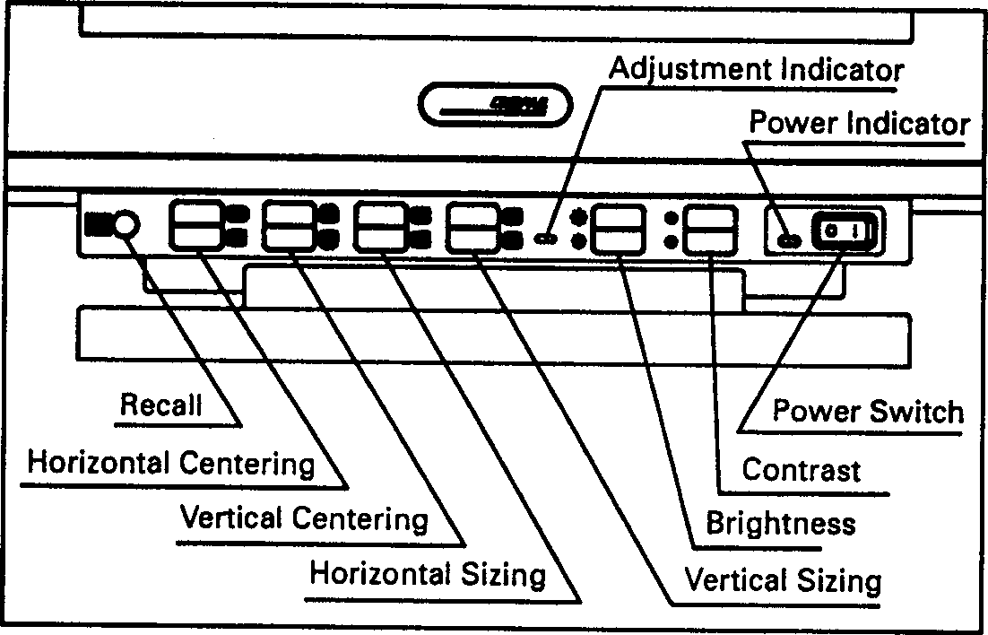
Controls and Indicators

Adjustment Indicator The adjustment indicator provides information on whether an adjustment is being made or the limit of the adjustment range has been reached.

If you are not at the limit of the control range, (up or down) when you press a control, the adjustment indicator light will come on.

If you are at the limit of the control range, when you press a control, the adjustment indicator light will not come on. This indicates that no further adjustments can be made.

QVision Operations and Installation Guide 2-9

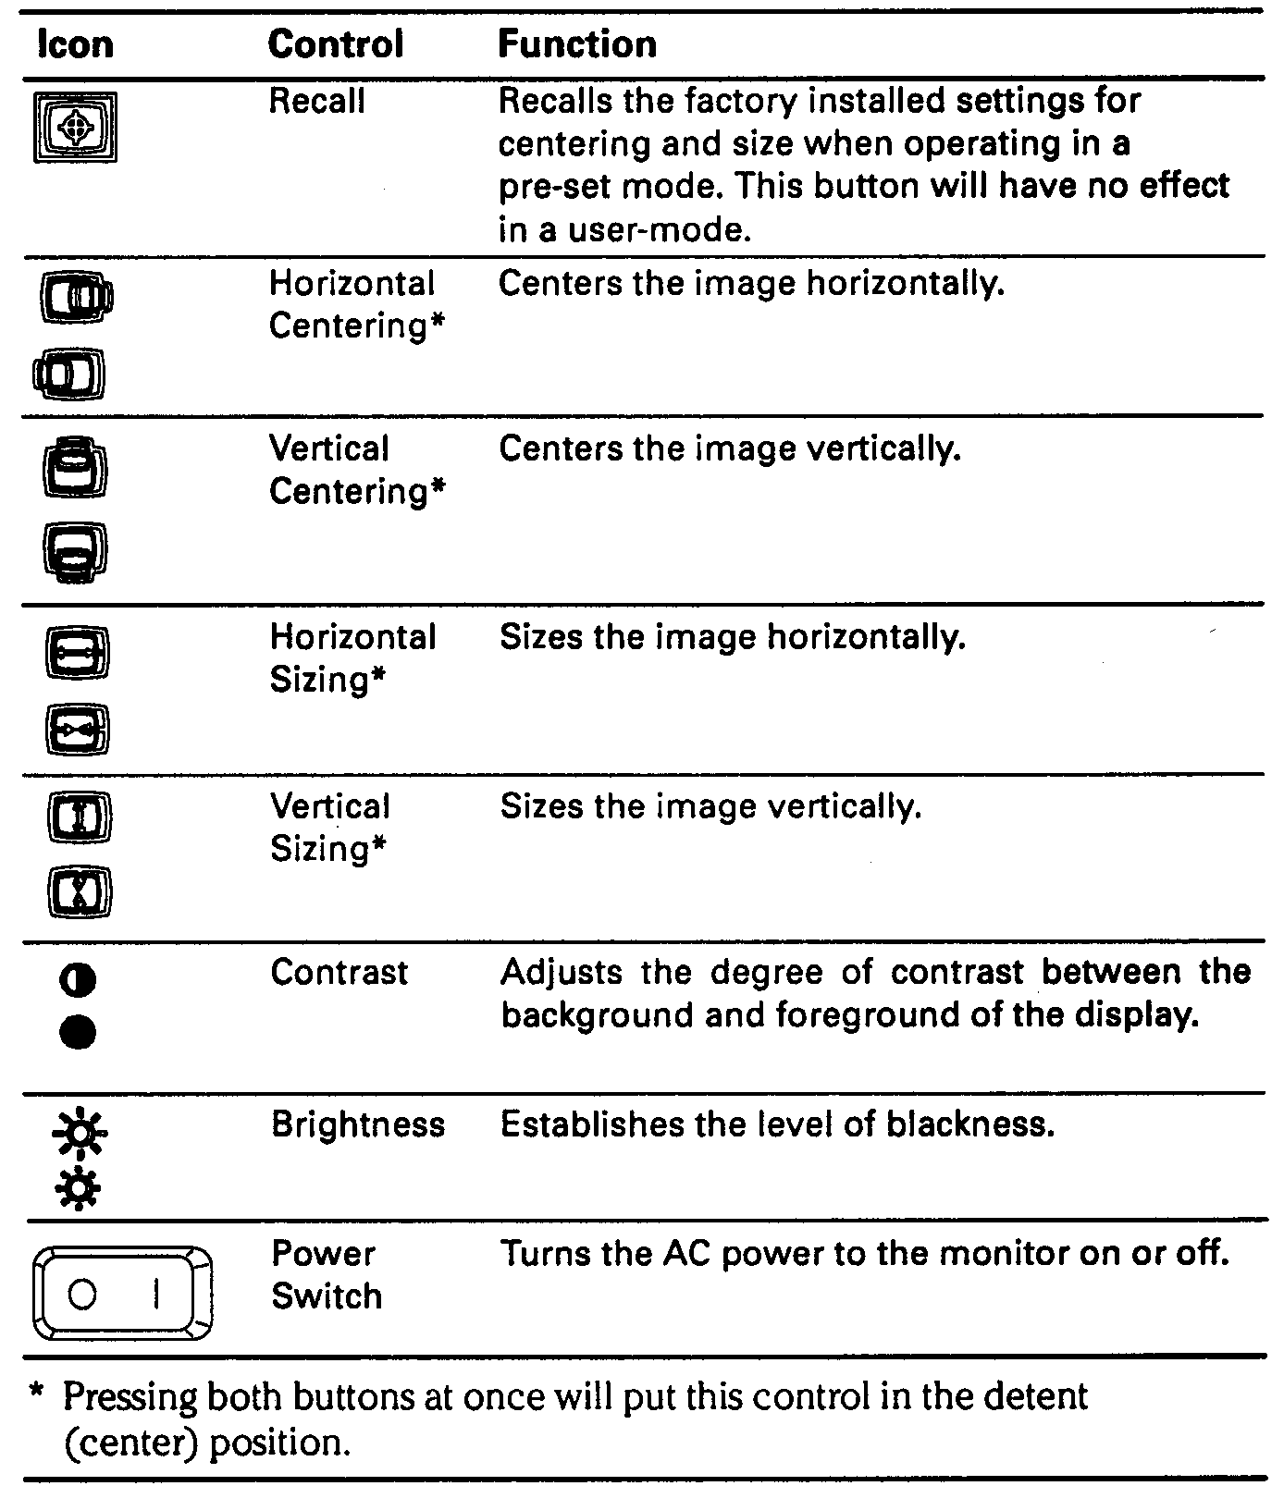
The following table lists the functions of each control:

QVision Operations and Installation Guide 3-1

Chapter 3

CARE AND MAINTENANCE

This chapter explains how to care for and maintain your QVision Graphics System from Compaq in normal everyday use. It also contains a troubleshooting guide.

PROTECTING THE MONITOR

To protect your monitor from overheating and other types of damage, follow these suggestions:

- Place the monitor at least 4 inches (10 cm) away from the wall.

- Never cover the ventilation slots with any type of material, including cloth.

- Never allow liquid to drip into the monitor.

- Do not place plants on top of the monitor. Water or dirt from the plant may fall into the vents.

- Do not block the bottom ventilation slots by operating the monitor on a surface that will conform to the bottom of the monitor, such as a bed, sofa, or rug.

- Operate the monitor only in a properly ventilated area.

- Do not expose the monitor to excessive moisture or dust.

- Never place the monitor on an unstable stand.

- In a two-monitor system, place the monitors as far apart from each other as possible to lessen interference between them.

- Place the monitor away from implements having strong magnetic fields, such as high capacity transformers or electric motors.

QVision Operations and Installation Guide 3-2

CLEANING THE MONITOR

To clean the monitor follow these steps:

- Turn off the monitor and the computer.

- Dust the monitor by wiping the screen and the cabinet with a soft, clean cloth.

If the screen requires more than dusting, use an anti-static CRT screen cleaner.

⎯⎯⎯⎯⎯⎯⎯⎯⎯⎯⎯⎯⎯⎯⎯⎯⎯⎯⎯⎯⎯⎯⎯⎯⎯⎯⎯⎯⎯⎯⎯⎯
CAUTION: Do not use benzene, thinner, or any volatile substances to clean the unit. These chemicals may
damage the cabinet finish.
⎯⎯⎯⎯⎯⎯⎯⎯⎯⎯⎯⎯⎯⎯⎯⎯⎯⎯⎯⎯⎯⎯⎯⎯⎯⎯⎯⎯⎯⎯⎯⎯

SHIPPING THE MONITOR

To ship the monitor, follow these steps:

1. Turn off the monitor and the computer.

2. Disconnect the signal cable from the computer.

3. Disconnect the power cable from the AC power outlet.

4. Unplug the cables from the back of the monitor.

- Place the monitor in its original box with its original packing material.

⎯⎯⎯⎯⎯⎯⎯⎯⎯⎯⎯⎯⎯⎯⎯⎯⎯⎯⎯⎯⎯⎯⎯⎯⎯⎯⎯⎯⎯⎯⎯⎯
WARNING: The monitor weighs approximately 45 pounds. Use care in moving it.
⎯⎯⎯⎯⎯⎯⎯⎯⎯⎯⎯⎯⎯⎯⎯⎯⎯⎯⎯⎯⎯⎯⎯⎯⎯⎯⎯⎯⎯⎯⎯⎯

QVision Operations and Installation Guide 3-3

SERVICING THE MONITOR

The monitor is designed to give you a long period of trouble-free operation. To help extend the useful life of your monitor, follow the procedures listed below:

- Do not simultaneously set the brightness and contrast controls at the maximum levels.

- Turn the monitor off when it will not be used for an extended period of time (such as overnight).

If your monitor display is not functioning properly and you are unable to restore the normal display by adjusting the controls discussed in this guide, contact your Authorized COMPAQ Reseller or your Authorized COMPAQ Service Provider.

QVision Operations and Installation Guide 3-4

TROUBLESHOOTING

The following table suggests solutions for problems you may encounter when using the monitor,
especially for the first time.

Problem | Probable Cause | Solution
No picture | The power switch for the  computer or the monitor is  not turned on. | Turn the power  switches on.
 | The cables are misconnected or disconnected. | Check 15-pin connector. Check BNC connectors. Check AC contact on  the power cable.
 | The brightness/contrast  adjustments are not set  correctly. | Check the brightness  and contrast  adjustments.
Unstable  Picture | The signal cable is  misconnected  The compatible video mode  (VGA or above to 1024 x 780)  is not being used. | Check BNC connectors.  Check the documentation included with the video  board.
Missing color | The BNC cables are  misconnected. | Check BNC connectors.
Display not full  or too small | Improper adjustments for  horizontal or vertical size. | Non-standard signals  may require special  adjustments. Contact  your Authorized  COMPAQ Reseller or  your Authorized  COMPAQ Service  Provider.

QVision Operations and Installation Guide A-1

SPECIFICATIONS

Specifications
QVision Graphics System from Compaq
Dimensions |  |  | 15" |  |  |  | 17"
 | Height  Depth  Width  Weight |  | 16.6 in  16.6 in  16.1 in  45 lb |  | 39.9 cm  42.2 cm  40.9 cm  20.4 kg |  | 17.1 in  17.4 in  17.9 in  56.6 lb |  |  | 43.43 cm  44.29 cm  45.46 cm  25.6 kg
Display
 | CRT |  | 15 in |  | 35.5 cm |  | 17 in |  |  |  | 43 cm
 | Type |  | Color
 | Maximum Graphics
 | Resolution |  | 1024 x 768 up to 72 Hz Non-Interlace
 | Text Mode |  | 720 x 400
 | Character Display |  | 80 x 25
 | Color Scale |  | Infinite, Analog Input 75 ohm
 | Brightness and Contrast |  | Adjustable
 | Bandwidth |  | 75 MHz
 | Horizontal Frequency |  | 31.5 kHz to 58 kHz
 | Vertical Frequency |  | 50 to 100 Hz
Temperature Range
 | Operating |  | 50° to 104°F |  |  |  | 10° to 40°C
 | Non-Operating |  | 32° to 140° F |  |  |  | 0° to 60°C

QVision Operations and Installation Guide A-2

The following input sync information is presented for technically sophisticated users who want to connect the monitor to a non-COMPAQ computer. You may need to provide your own cables or connectors to the computer.
Non-technical users should consult an Authorized COMPAQ Reseller or an Authorized COMPAQ Service Provider.

ACCEPTABLE SIGNAL
TRANSMISSION SCHEMES

Composite Sync on Green

This scheme uses 3 of the 5 BNC connectors. The other two are not used and should not be connected.

Video Input Characteristic: Typical input impedance of the videoamps is 75 ohm.

Video Signal Definition: The three video inputs are red, green, and blue analog signals, where 660 milli-volts is the maximum signal amplitude above the black level. The green video input signal contains sync information.

Black Level: The black level is 0.054 volts above the front/back porch reference level.

Sync Signal Definition: Horizontal and vertical synchronization signals are integrated onto the green video signal, using RS-343-A voltage levels.

Composite Sync, Separate Analog
Videos

This scheme uses 4 of the 5 BNC connectors. The other one is not used
and should not be connected.

Video Input Characteristic: Typical input impedance of the videoamps is
75 ohm.

Video Signal Definition: The three video inputs consist of red, green, and
blue signals, each with an associated ground, driven into a terminated
line. The video signals are analog, where 0 volts corresponds to black,
and 0.7 corresponding to white, and 1.00 volt is the maximum allowable
signal amplitude above the 0 volt reference.

QVision Operations and Installation Guide A-3

Sync Signal Definition: Horizontal and vertical synchronization signals conform to the RS-343-A voltage level standards and use the normal horizontal input.

Separate TTL Syncs, Separate
Videos

This scheme uses all 5 of the BNC connectors.

Video Input Characteristic: Typical input impedance of the videoamps is 75 ohm.

Video Sync Definition: The three video inputs consist of red, green, and blue signals, each with its associated return, driven into a terminated line. The video signals are analog levels, where 0 volts corresponds to black, and 700 millivolts is the maximum signal amplitude.

Sync Signal Definition: This scheme utilizes separate horizontal and vertical synchronization signals which are generated by a TM or TTL equivalent source.

Input Voltage Levels: All signal levels between 0 and 0.8 are defined as logic 0. All signal levels greater than 2.0 are defined as logic 1.

Sync Polarities: Both horizontal and vertical sync signals are defined as negative true.

QVision Operations and Installation Guide B-1

NATIONAL POWER CORD SET
REQUIREMENTS

Power cord set selection is determined by the following facts:

1. The cord set must be approved for the country in which it is used.

2. The appliance coupler (that is, the connector to the device itself, not
the wall plug) must have a configuration for mating with a CEE22/IEC
320 appliance inlet (Standard Sheet C14).

U.S. AND CANADA

1. The cord set must be UL Listed and CSA Certified.

2. The minimum specifications for the flexible cord are as follows:
No. 18 AWG
Type SV or SJ
3 conductor

3. The cord set must have a rated current capacity of at least 10 amperes.

4. The attachment plug must be an earth-grounding type with a NEMA 5-15P (15A, 125V) or NEMA 6-15P (15A, 250V) configuration.
QVision Operations and Installation Guide B-2

OTHER COUNTRIES

1. The cord set fittings must bear the certification mark of the agency responsible for evaluation in a specific country. Acceptable agencies include the following:

BSI (United Kingdom) NEMKO (Norway)
CEBEC (Belgium) OVE (Austria)
DEMKO (Denmark) SEMKO (Sweden)
EANSW (Australia) SEV (Switzerland)
SETI (Finland) UTE (France)
IMQ (Italy) VDE (Germany)
KEMA (The Netherlands) MITI (Japan)

2. The flexible cord must be of a HAR (harmonized) type HO5VVF
3-conductor cord with a minimum conductor size of .03 square inches (1.0 square millimeter).

3. The cord set must have a current capacity of at least 10 amperes and a nominal voltage rating of 125 or 250 VAC, as required by the specific country's power system.

For more information about power cord set requirements, consult your Authorized COMPAQ Computer Reseller or your Authorized COMPAQ Service Provider.

QVision Operations and Installation Guide C-1

Appendix C

ELECTROSTATIC DISCHARGE

A discharge of static electricity from a finger or other conductor may
damage system boards or other static sensitive devices. This type of
damage may reduce the life expectancy of the device.

PREVENTING ELECTROSTATIC

DAMAGE

To prevent electrostatic damage, observe the following procedures:

- Avoid touching pins, leads, or circuitry.
- Be properly grounded when touching a sensitive component or assembly.

QVision Operations and Installation Guide C-2

METHODS OF GROUNDING

Use one or more of the following measures when handling or installing
Electrostatic-sensitive parts:

- Use a wrist strap connected by a ground cord to a grounded workstation or to the computer chassis. Wrist straps are flexible straps with a minimum of 1 megohm +/- 10 percent resistance in the ground cords. To provide a proper ground, wear the strap snug against the skin.

- Use heelstraps, toestraps, or bootstraps at standing workstations. Wear the straps on both feet when standing on conductive floors or
dissipating floor mats.

- Use conductive field service mats.

- Use a portable field service kit with a folding static-dissipating work mat.

⎯⎯⎯⎯⎯⎯⎯⎯⎯⎯⎯⎯⎯⎯⎯⎯⎯⎯⎯⎯⎯⎯⎯⎯⎯⎯⎯⎯⎯⎯⎯⎯
IMPORTANT: For additional information on static electricity or assistance with the installation of this product, contact your Authorized COMPAQ Reseller or your Authorized COMPAQ Service Provider.
⎯⎯⎯⎯⎯⎯⎯⎯⎯⎯⎯⎯⎯⎯⎯⎯⎯⎯⎯⎯⎯⎯⎯⎯⎯⎯⎯⎯⎯⎯⎯⎯

