

SoundMAX4 XL
with AudioESP®
Installation
and
User Guide
©Analog Devices, Inc. 2002

Revision 1.0

Integrated Audio Group
Analog Devices, Inc.
Analog Devices, Inc. Confidential
COntents
Introduction 4
Description 4
System Requirements 5
Installing the SoundMAX Software 6
Installation of SoundMAX4 XLSoftware 6
Verification that the SoundMAX4 XL Software is Installed and Functions Correctly 7
Un-installation of SoundMAX4 XL Software 9
SoundMAX4 XL Installation Support 10
2/4/6 Channel Speaker Configuration 11
Setup Wizards 14
Preferences Options 15
Listening Environment Options 16
Speaker Setup 17
Virtual Theater Surround 17
Acoustic Environments 17
Virtual Ear 18
MIDI Music Synthesizer Controls 19
SoundMAX Synthesizer 19
Synthesizer Default Sound Set 20
Defaults Button 20
MICROPHONE Options 21
Setup Wizard 21
Microphone Enhancements 22
DLS Loader Application 23
Document History

Revision | Date | Author | Description of Change
0.1 | 3/10/2003 | John Howley | Initial release
0.5 | 3/19/2003 | John Howley | General cleanup  Added speaker configuration section
1.0 | 3/31/2003 | John Howley | Final release

Introduction

Description
SoundMAX® 4 XL with AudioESP™, from Analog Devices, delivers the ultimate audio experience on today’s PCs for gamers, musicians, audiophiles, and the business desktop. SoundMAX is a powerful combination of software and Analog Devices’AC’97 audio codecs integrated on your motherboard, providing full-featured soundcard functionality and more. SoundMAX takes advantage of today’s advanced CPUs and motherboards to implement high-quality audio synthesis/rendering, 3D sound positioning, and advanced voice-input technologies.

Table 1.1 shows the SoundMAX 4 XL features.

 | SoundMAX Features
Audio Quality | - Professional 20-bit DACs with 100dB SNR  - Up to 96 kHz sampling rate
Audio Compatibility | - Microsoft® DirectSound™  - Dolby Digital pass-through  - 5.1 playback over two speakers via Virtual Theater Surround™ or over 6 speakers via CNR card (DVD software must support 5.1 decoding)
Game Compatibility | - Microsoft® DirectSound3D™ via Sensaura® 3D Positional Audio™ and MultiDrive™ for more realistic 3D positioning  - EAX™1.0 / 2.0 via Sensaura® EnvironmentFX™  - A3D™ 1.0 compliant  - I3DL2™ compliant  - Sensaura® MacroFX™ and ZoomFX™  - SoundMAX SPX Animated Audio
Wavetable Synthesizer | - Downloadable Sounds (DLS2) Music Synthesizer  - GeneralMIDI with 4MB Professional soundset  - XG compatible with 1.2MB XGlite soundset  - Reverb and Chorus integrated effects
External Connectors | - Stereo line output  - Stereo headphone output with amplifier  - Stereo line input  - Mono(or Stereo) mic input with preamp
Internal Connectors | - CD input  - Aux input
Data Bus | - 266MB/sec AHA bus

Table 1.1 SoundMAX Features

If an optional multi-channel CNR soundcard solution is installed, you will have additional features available to you including:
- Discrete 6-channel analog outputs for interactive games with 3D audio; immersive DVD movies with Dolby Digital™ and/or DTS™ surround sound (if supported by your software DVD player)

- Support for an optical digital output to directly connect your computer to digital speakers or a home theater system
With SoundMAX4 installed you will have support for headset-free high-quality voice input with an Andrea SuperBeam Microphone.

System Requirements
SoundMAX4 XL software requires the following:

- Windows 98 Second Edition, Windows Millennium (ME), 2000, XP Home, or XP Professional

- 64 MB RAM for Windows 98SE, ME, or 2000

- 128 MB RAM for Windows XP Home or XP Professional

- DirectX 8.1 or later

- Installation Media

- CD-ROM Drive for compact disc

- Internet connection for download file

- 30 MB of free hard disk space

- Headphones or amplified speakers to listen to audio output

- Andrea “SuperBeam” Stereo Array Microphone for DSDA™ speech input enhancements (optional)

Installing the SoundMAX Software

SoundMAX 4 XL requires Microsoft Windows 98SE, Windows Millennium (ME), Windows 2000, or Windows XP (Professional or Home Edition). Ensure that one of these operating systems is installed and functioning correctly before proceeding.

Installation of SoundMAX4 XLSoftware
- Turn on your computer.

Note: When Windows starts up, it may automatically attempt to install the default drivers provided by Microsoft. If the “New Hardware Found” dialog box appears, click the Cancel button. If the dialog box does not appear, continue.

- Insert the SoundMAX installation CD or locate the SoundMAX installation files on your hard drive that you have downloaded from the Internet or local network.

- Double-click the "Setup” icon in the main installation folder and follow the installation instructions on the screen.

Note: If you have a CD-ROM, it may self-run Setup after insertion.

The SoundMAX4 XL installation main components are:

- SoundMAX WDM Driver
- SoundMAX Sensaura 3D
- SoundMAX Microphone Filter
- SoundMAX MIDI Synthesizer
- SoundMAX Audio Control Panel
- SoundMAX Audio PnP

- After reboot, check to see if the SoundMAX 4 XL icon (a white triangle on a blue background) appears on the taskbar in the system tray.

Figure 2.2 shows the SoundMAX 4 XL icon.

Figure 2.2 SoundMAX 4 XL Icon

Verification that the SoundMAX4 XL Software is Installed and Functions Correctly

If SoundMAX4 XL is properly installed, then the icon labeled “SoundMAX” will be found in the Control Panel and in the system tray. Double-click on the icon to launch the SoundMAX4 XL audio control panel:

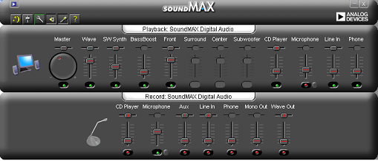

Figure 2.3 SoundMAX4 XL Audio Control Panel

To verify the SoundMAX audio codec drivers are properly installed you can also:

- Click the Start button and select “Control Panel” from the list.

- In the Control Panel, double-click on the System icon.

- In the System Properties window, click on the “Hardware” tab, and then click the “Device Manager” button.

Note: This procedure may vary slightly with different operating systems.

Within the “Sound, video and game controllers” folder, “SoundMAX Integrated Digital Audio” appears. The SoundMAX icon may slightly vary in appearance with different operating systems.

If “SoundMAX Integrated Digital Audio” does not appear, or if a red “x” or a yellow exclamation point (“!”) is present, the installation was not successful. Uninstall, restart, and then reinstall according to the instructions in section 2.1. See section 2.3 for un-installation instructions.

Figure 2.4 shows correct driver functionality in the Device Manager.
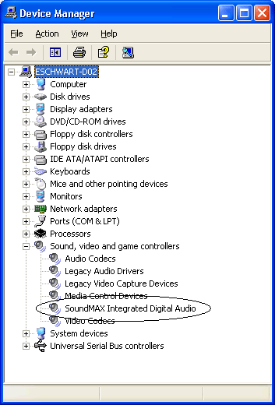

Figure 2.4 Correct Driver Functionality

Un-installation of SoundMAX4 XL Software
Un-installation is straight forward as follows:

- Click the Start button and select “Settings”, then “Control Panel” from the list.

- Double-click “Add/Remove Programs”.

- Select “SoundMAX” from the list and click “Change/Remove”.

Note: This procedure may vary slightly with different operating systems.

- Select “Remove” from the list of choices and click ‘OK .
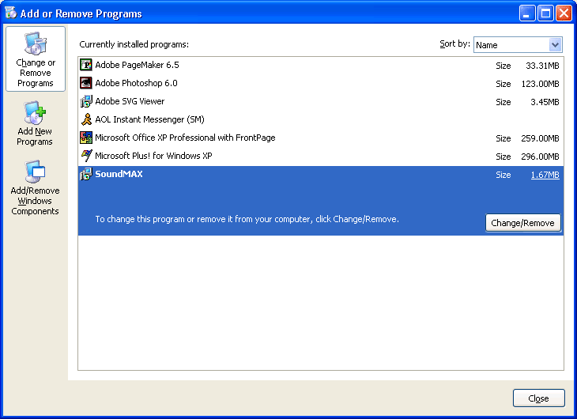

Figure 2.5 Add or Remove Programs

Figure 2.6 shows the InstallShield Wizard in the Control Panel.

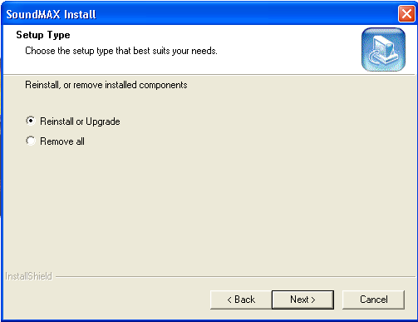

Figure 2.6 InstallShield Wizard

SoundMAX4 XL Installation Support

If you experience any other installation issues, contact your specific computer or motherboard manufacturer for more information. For basic problems, please reference the Frequently Asked Questions (FAQs) section of the software by right-clicking on the Analog Devices taskbar icon and selecting SoundMAX FAQs.

If the SoundMAX software package still does not install, but the default driver works, you will need to check with your computer/motherboard manufacturer to confirm that you have the proper software installation package, and that you have an Analog Devices, Inc. audio subsystem in your computer.

If you are experiencing no audio output at all, please contact your computer/motherboard manufacturer.

Note: This installer contains certified drivers that have gone through the Windows Hardware Qualification Labs (WHQL) process. Microsoft certifies these drivers to work on this system.

2/4/6 Channel Speaker Configuration
The speaker configuration can be changed in one of two ways: 1) Using pull-down menu; 2) auto reconfiguration using AudioESPTM

- Pull-down Menu

Note: You must use this method if AudioESPTM is turned OFF.

The speaker configuration to/from 2-chanel, 4-channel and 6-channel can be user-selected using the pull-down menu under the Preferences tab as illustrated here:

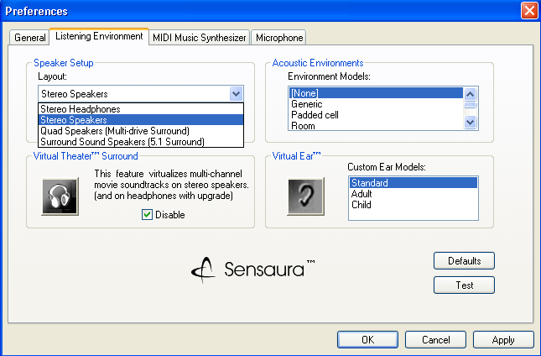

Select the desired speaker configuration from the pull-down list , then click Apply or OK.

- AudioESPTM

AudioESPTM is the intelligent audio device detection system in SoundMAX4 XL that senses audio peripherals and identifies them to the user by way of pop-up messages. After a user confirms (or selects the correct device from the list) the device plugged into the jack, if it is not supported by that jack the user will get a warning and will be informed to move to the correct jack. When the device is in the correct jack, if it is a powered speaker (as in the case of stereo speakers, 4 speaker systems, 5.1 speaker systems) the user can have AudioESPTM automatically change the speaker setup to match the current speakr configuration.

2-speaker Configuration
When plug in stereo powered speaker in Line Out (green) jack you get:

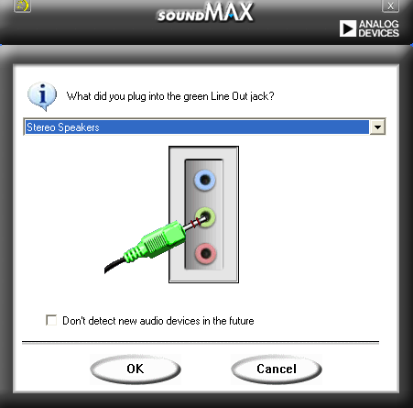

Clicking on OK provides the option to reconfigure the speakers as follows:

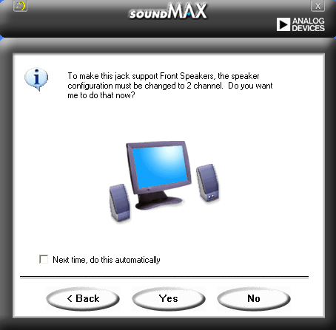

Click on YES to re-configure to 2-channel stereo speaker mode.

Note: If “Change Speaker Configuration Automatically” is checked under Preferences this screen will be bypassed.

Finally, click OK on last screen. Your system is now reconfigured to work correctly.

4-Channel Speaker Configuration
When plug in 4 speakers, Front (green) and Rear (blue) jacks you will get a similar sequence as the 2-channel scenario as follows:

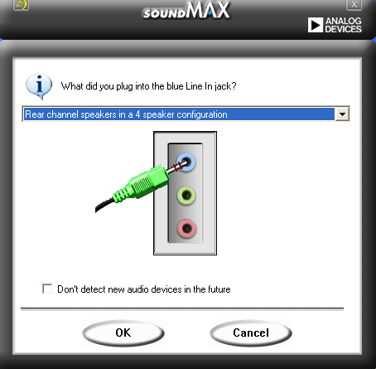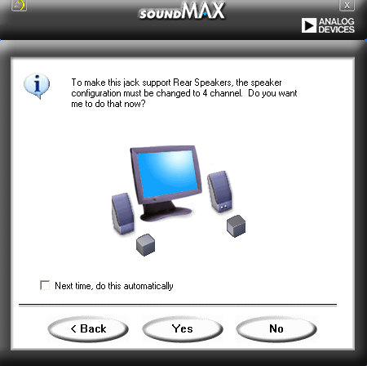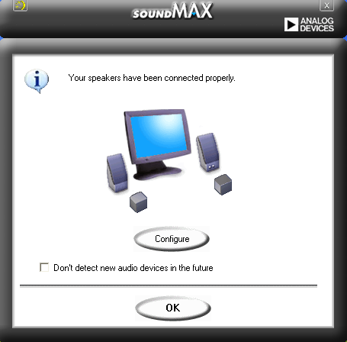

Note: You will not get the second screen if “Change Speaker Configuration Automatically” is checked under Preferences

6-Channel Speaker Configuration
When plug in 6 speakers, Front (green), Rear (blue), and Center/Subwoofer (pink) jacks you will get a similar sequence as follows:

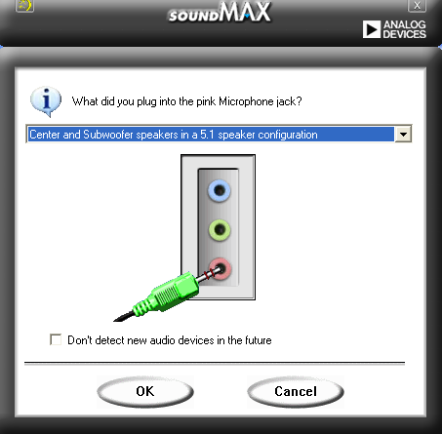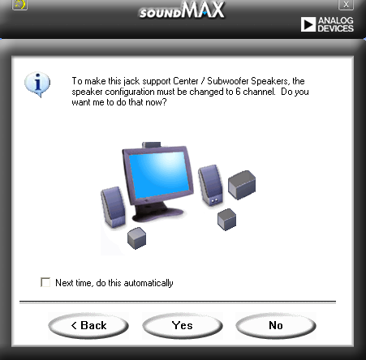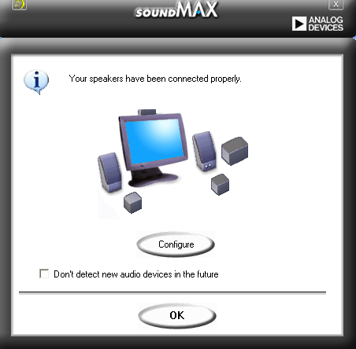

Note: You will not get the second screen if “Change Speaker Configuration Automatically” is checked under Preferences.

Setup Wizards
The speaker and microphone setup wizards allow fine tuning of the gain/attenuation of the inputs/outputs for optimal audio performance. The setup wizards can be launched by clicking the “Configuration” button when AudioESPTM detects and verifies a newly connected peripheral, or by clicking on on the main audio control panel application window.

Speaker Wizard

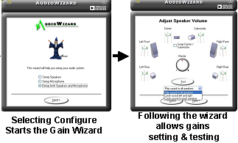

Microphone Wizard

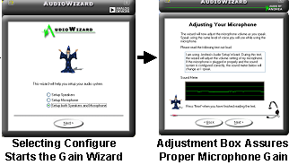

Preferences Options
The “Preferences” page of SoundMAX4 XL allows user selection of various controls displayed on the main GUI, as well as options for Audio ESP….as follows:

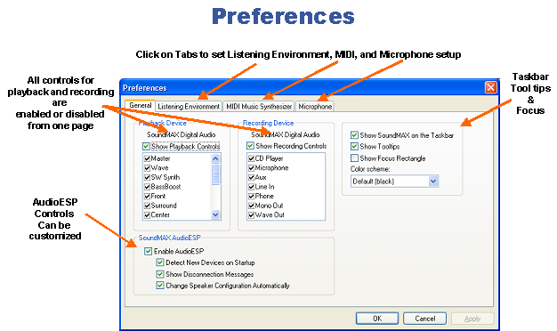

Figure 2.7 Preference Window Options

AudioESPTM
Audio Enumeration and Sensing Process technology by Analog Devices. It is a smart sensing technology in SoundMAX4 XL that notifies users of audio device connect/disconnect events, and also identifies the device to the user (microphone, speaker, headphone, etc), requests user device confirmation, then confirms correct connections or warns that a particular device is not supported in that jack. The main aim is to guard against incorrect connection of audio peripherals to the audio jacks. The user options available are:

Enable AudioESP: Enable/disable the smart sensing and peripheral identification engine

Detect New Devices On Startup: When Windows starts up it scans the audio jack to notify users of connection changes since the last time the OS was running.

Change Speaker Configuration Automatically: On a multi-channel speaker system (2, 4, 6) when speakers are plugged in the Windows speaker configuration must be changes to allow the correct audio channels to play out the correct speakers, i.e Front from front speakers, Center from Center, Subwoofer form Subwoofer, Rear from rear, etc. Checking this options enables Windows to make this configuration change automatically (no user prompting) when speakers are plugged in or unplugged with AudioESP running.

Listening Environment Options
This tab provides options for audio rendering:

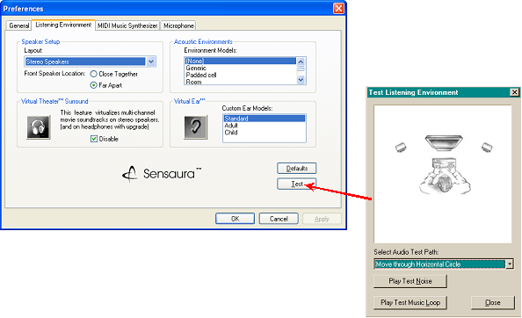

SoundMAX4 XL includes support for the following technologies:

- SoundMAX SPX™ Animated Audio. This is a next-generation game audio technology that interactively creates and manipulates hyper-realistic sound effects in real-time based on events occurring during game play.

- 3DPA™. This is a three-dimensional Positional Audio used to recreate 3D audio environments by spatializing DirectSound3D audio streams.

- MultiDrive™ 5.1. This implements multiple HRTF algorithms over a 5.1 speaker setup to more accurately position sounds in the 3D audio environment.

- Virtual Ear™. This support for the Virtual Ear upgrade fine-tunes the 3D algorithms for each individual user.

- EnvironmentFX™. This creates immersive gaming environments by supporting the EAX environmental audio extensions used in a variety of today’s computer games.

- MacroFX/ZoomFX™. This brings more realism to super-close/super-large sound objects.

- Virtual Theater Surround. This enables movie theater multi-channel audio over two speakers by positioning “virtual” surround speakers in the rear.

- Support for Headphone Theater™ upgrade. This support for the Headphone Theater upgrade decodes Dolby Digital and DTS DVD movie soundtracks and realistically spatializes them for playback in headphones.

Speaker Setup
With SoundMAX 4 XL, it is possible to optimize your audio listening environment for the best possible experience. By selecting your exact speaker configuration, SoundMAX is able to tune the 3D algorithms for your particular listening environment, and to enable or disable the optional multi-channel outputs. This is especially important for 3D gaming, where accurate positioning of a sound is very important. If you wish to understand more about these 3D algorithms, then please see the section on Head Related Transfer Functions (HRTFs) on the www.sensaura.com website.

Choose from the following configurations:

- Stereo Headphones. Choose this if you will be listening on headphones.

- Stereo Speakers. Choose this if you have two stereo speakers (with or without a separate subwoofer). These speakers may be integrated into your monitor or laptop, or separate speakers on your desktop. If you have non-integrated speakers, place the speakers on either side of your computer, far enough away from it so that it will not block the path of the sound, and then angle them toward you.

- Quad Speakers. Surround sound systems without Center or Subwoofer.

- Surround Sound Speakers (5.1). Complete surround sound system speaker set.

You can also further tune your listening environment by selecting the appropriate location settings for your front speakers:

- Close Together. This optimizes the sound for laptop and monitor speakers, or if you have your speakers close to your monitor.

- Far Apart. This optimizes the sound for speakers spread out on your desktop or on a big home stereo system.

Virtual Theater Surround
If you are watching movies with a multi-channel soundtrack and do not have a 4- or 5.1-channel speaker setup, SoundMAX 4 XL is capable of creating “virtual surround speakers” through your stereo speaker setup. These advanced audio algorithms actually create a full surround sound experience out of two speakers.

- Use the check box to enable and disable Virtual Theater Surround. When there is a check in the check box, the Virtual Theater Surround is disabled. When the check box is empty, the Virtual Theater Surround is enabled.

- If you would like to enable the Virtual Theater Surround experience when using headphones, you can purchase an upgrade by clicking on the Headphone icon button. After purchasing and installing this upgrade, this feature will work automatically every time you watch a movie and select the ‘Stereo Headphones’ layout in the Speaker Setup section on the Listening Environment tab.

Acoustic Environments
Acoustic environments are virtual places where you can listen to your sounds and music. Like sonic landscapes, these environment models simulate everything from concert halls to tunnels.

You can change your listening space by clicking on a new environment model in the list provided. The models are the same ones that are used in games that take advantage of Environmental Audio Extensions (EAX™) and are automatically enabled and changed by your games.

Virtual Ear
Virtual Ear stores custom ear models for different individual users. These models are individually tailored to each listener and will adjust the algorithms to each specific head and ear size. This creates a much more “personal” 3D immersion for today’s audio and gaming applications.

- You can change the ear model being used by clicking on a new custom ear model in the list provided. A couple of generic example models are included for you to try; they simulate the ears of an Adult or Child.

Figure 3.2 shows the Advanced Virtual Ear.

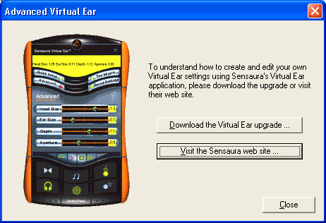

Figure 3.2 Advanced Virtual Ear

- If you would like to create your own customized personal ear models to be used with SoundMAX, you can purchase the 'Virtual Ear' upgrade application by clicking on the Ear icon button. After purchasing and installing this upgrade, the Ear icon button will directly launch Virtual Ear. This upgrade evolves your existing audio hardware into a cutting edge adjustable 3D audio device that brings gaming reality one step closer, both for the speaker and headphone user. The download provides a user-friendly "wizard" for setup purposes, together with both quick and advanced methods. The Quick option provides 25 pre-set head types for the listener to choose from, while the Advanced option provides complete optimization of in-depth parameters.

Note: The Sensaura Virtual Ear is contained in an install package that is independent of the SoundMAX4 XLsoftware and thus can be installed and uninstalled at anytime. As a consequence, the removal of the SoundMAX package will leave the Virtual Ear utility resident on the system, but it will not function correctly. Reinstalling the SoundMAX 4 XL software will restore the Sensaura Virtual Ear utility back to normal operation.

Defaults Button
Press the Defaults button to restore the default Speaker, Virtual Theater Surround, Acoustic Environment and Virtual Ear settings.

Test Button
Press the Test button to open the Test Listening Environment dialogue box. This allows you to play a test noise or music loop to ensure that all of your speakers are working.

MIDI Music Synthesizer Controls
MIDI support tab:

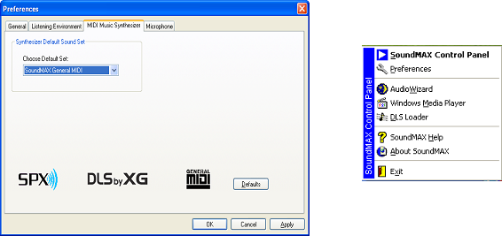
Right Click SoundMAX Icon

- MIDI™. This stands for Musical Instrument Digital Interface standard that defines the language that tells the synthesizer what to play.

- MIDI Voice. This is a single note or sound played on the SoundMAX synthesizer.

- General MIDI™ (GM). This is a sound set standard that contains 128 instrument sounds and a drum kit to allow the SoundMAX synthesizer to play any standard GM file. Most MIDI files found on the Internet conform to the general MIDI format. The SoundMAX synthesizer also contains a professional 4MB General MIDI sound set.

- .MID Files. This is a file format that contains a standard MIDI sequence and stores instructions for the computer on how to play a synthesizer to recreate a musical (or sound) experience, similar to the way a word processor can recreate a document from a file of nothing but characters.

- .DLS Files. This stands for a file format called DownLoadable Sounds that allows you to load custom sound sets into the SoundMAX synthesizer. A musician usually creates these sound sets for use with specific MIDI files. You can also create your own MIDI sequences and DLS sound sets with some 3rd-party software applications like Cakewalk and Awave. The SoundMAX synthesizer supports the newest Level 2 version of DLS to enhance your listening experience.

- .RMID Files. This is a single file format that contains both a standard MIDI sequence and a custom DLS sound set that was created specifically for this MIDI sequence.

SoundMAX Synthesizer
The SoundMAX synthesizer is a scalable all-software MIDI synthesizer supporting the General MIDI (GM) and Downloadable Sounds (DLS – Level 1 and 2) standards. It provides high quality wavetable playback through the PC’s sound output via the Microsoft DirectSound interface.

SoundMAX supports and enhances a wide variety of Audio Rendering Technologies that include Physical, Analog and Event Modeling (such as the “SoundMAX SPX Animated Audio” technology found in top game titles), as well as a professional Downloadable Sounds (DLS) synthesizer. DLS is the industry standard for wavetable synthesis and enables easy loading of different custom sound sets. DLS2 yields more expressive and dynamic instruments. SoundMAX also supports standard General MIDI (GM) sequence files and the new RMID file format, which combines a standard MIDI sequence file with a custom DLS sound set into one file.

The SoundMAX Synthesizer is assigned as the default MIDI device, so it is the synthesizer used by Windows when a MIDI file (file type .MID) is played with the Windows Media Player, a web browser, or other MIDI sequencer application.

The SoundMAX Synthesizer provides high quality software reverb and chorus effects that further enhance the final audio output. In addition, an XGlite™ mode is available for the playback of XG MIDI files.

SoundMAX offers a new concept called MAXvoice™. It addresses the proverbial ‘Maximum Number of Voices’. MAXvoice gives the end-user the maximum number of voices possible from their computer configuration. The end-user has the flexibility to decide exactly how many voices are needed. MAXvoice is fully scalable and is only limited by the CPU processing power available, although even the most complex MIDI sequences a consumer may encounter will very rarely exceed 64 voices. MAXvoice defaults to double this number at 128 voices.

Synthesizer Default Sound Set
You can choose the default sound set that the SoundMAX synthesizer will use to play MIDI files. Choose from the two choices that ship with SoundMAX 4 XL or browse for your own DLS2 formatted sound set:

- 4 MB GeneralMIDI. This is a professional DLS2 formatted General MIDI sound set with 128 high-quality instruments. Select this set to gain the highest quality playback of General MIDI files.

Defaults Button
Press the Defaults button to restore the Synthesizer Default Sound Set to its original settings.

MICROPHONE Options
Controls for the SuperBeam microphone array

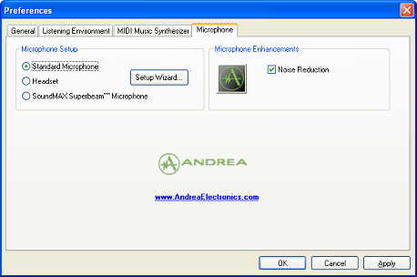

- PureAudio™ Noise Reduction. This provides noise cancellation to improve signal-to-noise ratio by eliminating ambient noise. It will work with any microphone and is enabled by default.

- DSDA™ (for use with the optional Andrea® SuperBeam™ Microphone). This provides “beam forming” technology used with the stereo array microphone for headset-free voice input. It eliminates audio that comes from the sides of the microphone and will only be enabled when an Andrea SuperBeam™ Microphone Array is present.

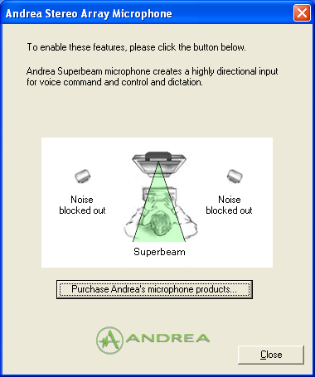
Andrea SuperBeam Microphone. This is a specialized stereo array microphone for enhanced high quality voice input. This device is actually made of two microphone elements mounted a short distance apart in a single enclosure. The stereo signal is then fed through the DSDA software built into SoundMAX 4 XL, which analyzes the signal and eliminates stray audio entering from the sides of the microphone. This creates a highly directional microphone that can pick up more accurate voice signals from a distance. You can use this microphone for headset-free, extended-range voice input; for speech recognition/dictation, voice command and control, and Internet communication. Please click on the Andrea logo button in ‘Microphone Enhancements’ to find out how to purchase an Andrea SuperBeam microphone. Please check your hardware specifications to ensure that you have a stereo microphone input jack on your PC.

Setup Wizard
Allows you to optimize the microphone input settings for your particular configuration. Choose “Standard Microphone” if you have an ordinary desktop microphone. Choose “Headset” if you have a wearable microphone that is positioned directly in front of your mouth. Choose ‘Andrea Stereo Array’ if you own one and have stereo microphone input capabilities.

Note: Setup Wizard can be run from the audio control panel top level GUI by clicking

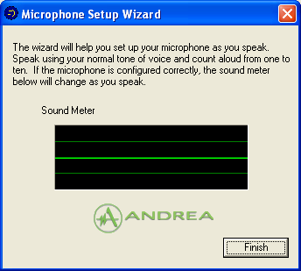
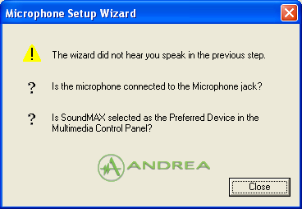

Note: Before using the “Setup Wizard”, ensure that the Microphone controls are not muted.

Microphone Enhancements
Noise Reduction. Activates the PureAudio™ 2.0 enhancement to help eliminate ambient noise from the voice input signal to provide a clean and clear signal to applications. This feature can be used with any microphone and is automatically enabled by the SoundMAX 4 XL default configuration. Use the check box to enable and disable PureAudio Noise Reduction. When there is a check in the check box, the noise reduction is enabled. When the check box is empty, the noise reduction is disabled.

DLS Loader Application

The SoundMAX synthesizer can play MIDI files that use custom DLS sound sets. To help load and play a MIDI file with its associated DLS file, launch the ‘DLS Loader’ application. You can load DLS based MIDI files either automatically or manually. By right-clicking the SoundMAX 4 XL icon (or via the SoundMAX install folder under Start Menu) you can launch the DLS Loader.

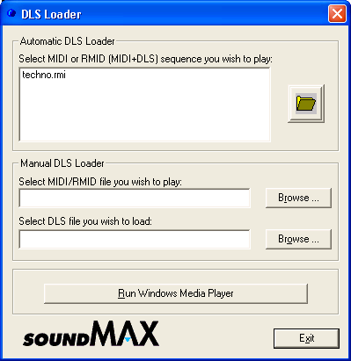

Automatic DLS Loader
There are two ways to automatically load and play a MIDI sequence in Windows Media Player using its associated DLS sound set:

- Press the folder button to browse for a .RMD file, and then press the Run Windows Media Player button. The self-contained DLS file will automatically be loaded into Media Player.

- Press the folder button to browse for a .MID file that has an associated .DLS file of the same name in the same directory, and then press the Run Windows Media Player button. You can select either file and both files will be loaded automatically.

Manual DLS Loader
In addition, you can manually load .MID and .DLS files to allow for files of different names and/or in different directories.

Press the respective Browse buttons to find the appropriate files, and then press the Run Windows Media Player button to launch the Media Player.

